9. Design and implement 2-bit half adder using logisim simulator.

Truth table:

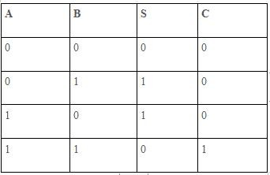

Circuit diagram:

